**SENSORS IN INDUSTRIAL AUTOMATION**

**DEFINITION: A SENSOR IN INDUSTRIAL AUTOMATION IS A DEVICE THAT DETECT CHANGES IN PROCESS VARIABLE SUCH AS TEMPERATURE, POSITION, SPEED, OR FLOW AND PROVIDES INPUT TO CONTROLLERS, PLCs, OR OTHER AUTOMATION SYSTEM FOR DECISION-MAKING AND CONTROL.**

**TYPES OF SENSORS:**

* **PROXIMITY SENSORS**
* **TEMPERATURE SENSORS**
* **PRESSURE SENSORS**
* **FLOW SENSORS**
* **LEVEL SENSORS**
* **PHOTOELECTRIC SENSORS**
* **SPEED AND RPM SENSORS**
* **VIBRATION SENSORS**
* **GAS AND CHEMICAL SENSORS**
* **POSITION AND DISPLACEMENT SENSORS**

PROXIMITY SENSORS**:**

* Detects the presence or absence of an object without contact.
* Types: Inductive, capacitive, ultrasonic.
* Application: Object detection on conveyor belts, packaging.

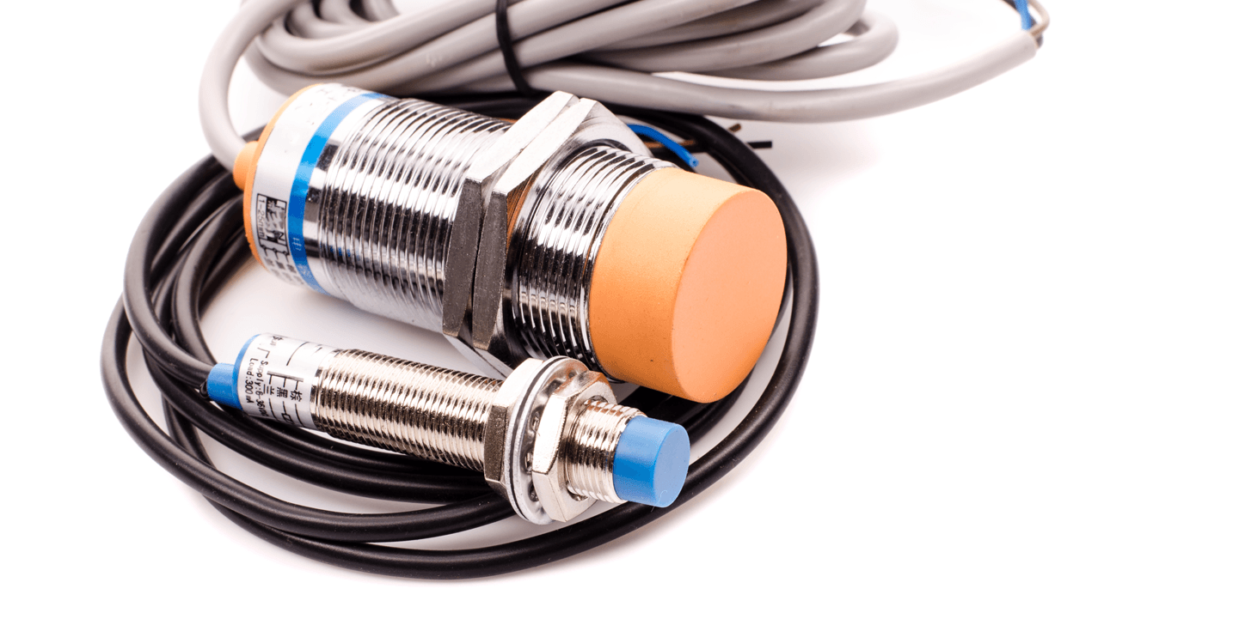

PROXIMITY SENSORS

TEMPERATURE SENSOR:

* Measure heat level in machines and environment.
* Examples: Thermocouples, RTDs, Infrared sensors.
* Application: Monitoring furnaces, motors, chemical processes.

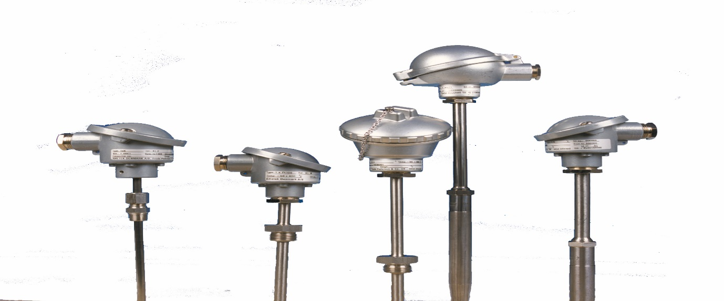

TEMPERATURE SENSOR

PRESSURE SENSOR:

* Measure pressure of gases and liquid.
* Examples: Hydraulic and pneumatic systems, boiler monitoring.

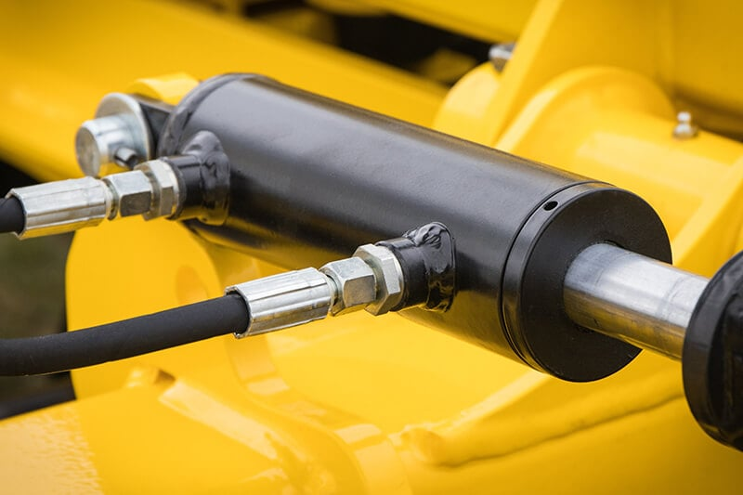

PRESSURE SENSOR

FLOW SENSOR:

* Measure flows rate of liquids or gases.
* Application: Oil and gas, water treatment, chemical plants.

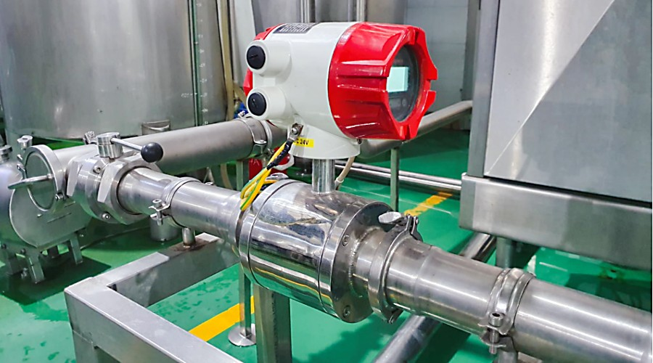

FLOW SENSOR

LEVEL SENSOR:

* Detect material level(liquid or solid) inside tanks, silos
* Types: Ultrasonic, capacitive, float type.

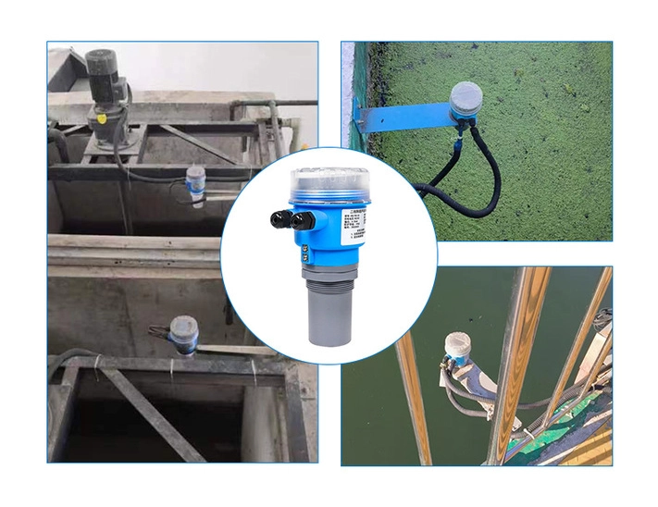

LEVEL SENSOR

PHOTOELECTRIC SENSORS:

* Use light beam to detect presence, position, or size of objects.
* Application: Packaging lines, counting system.

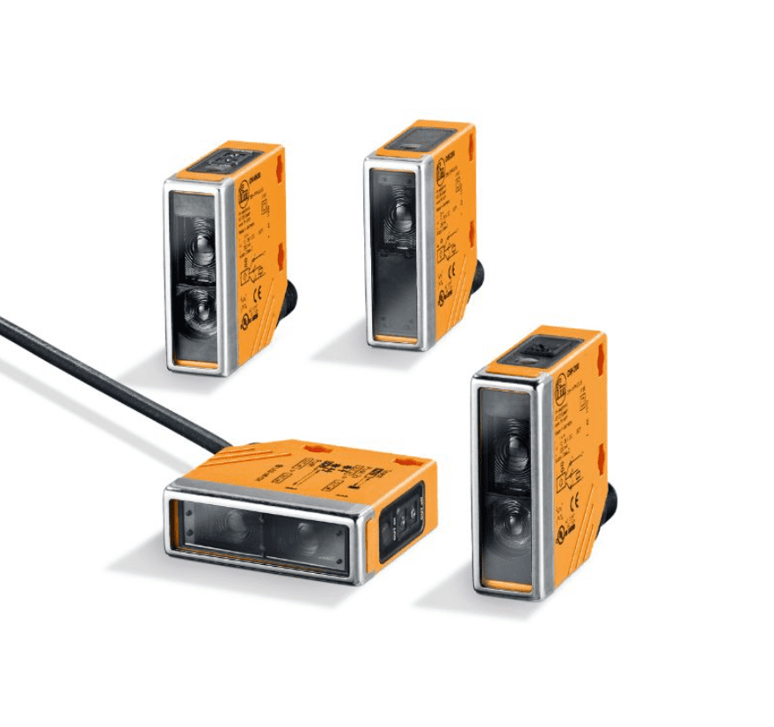

PHOTOELECTRIC SENSOR

CONCLUSION: INDUSTRIAL AUTOMATION SENSOR ARE ESENTIAL FOR MODERN MANUFACTURING,DRIVING EFFICIENCY, SAFETY, AND QUALITY BY PROVIDING REAL-TIME DATA AND ENABLING PRECISE CONTROL OF PROCCESS,INTEGRATING ADVANCED SENSOR IS VITAL FOR COMPANIES TO COMPETITIVE,ACHIEVE SUSTAINABILITY GOALS AND BUILT MORE INTELLIGENT INDUSTRIAL FUTURE